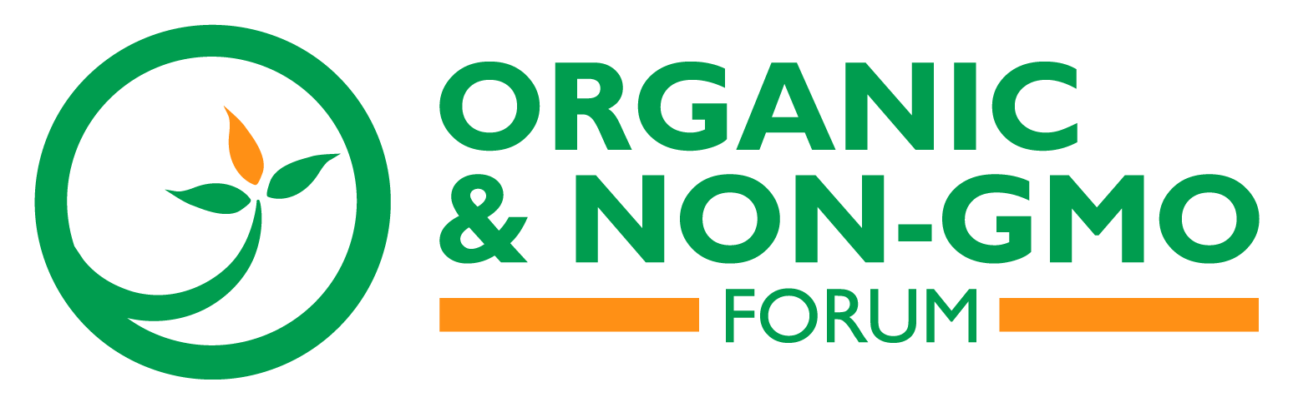 | PR CONTACT:  Michelle Pelletier-Marshall, 978.887.8800, x117  mmarshall@highquestpartners.com

On bioengineering and fraud: Organic & Non-GMO Forum tackles hottest industry topics

ST. LOUIS, July 24, 2018 – Hundreds of producers, processors, merchandisers and service providers in the industry will gather to discuss the most pressing issues at the fourth annual Organic & Non-GMO Forum, here, October 29-30 at the Hyatt Regency St. Louis at the Arch.

From what’s new in gene editing tools to how the long-awaited USDA National Bioengineered Food Disclosure Standard is shaping up to what’s being done to stop fraud in the organic sector, the forum’s accomplished speakers will deliver on the latest developments.

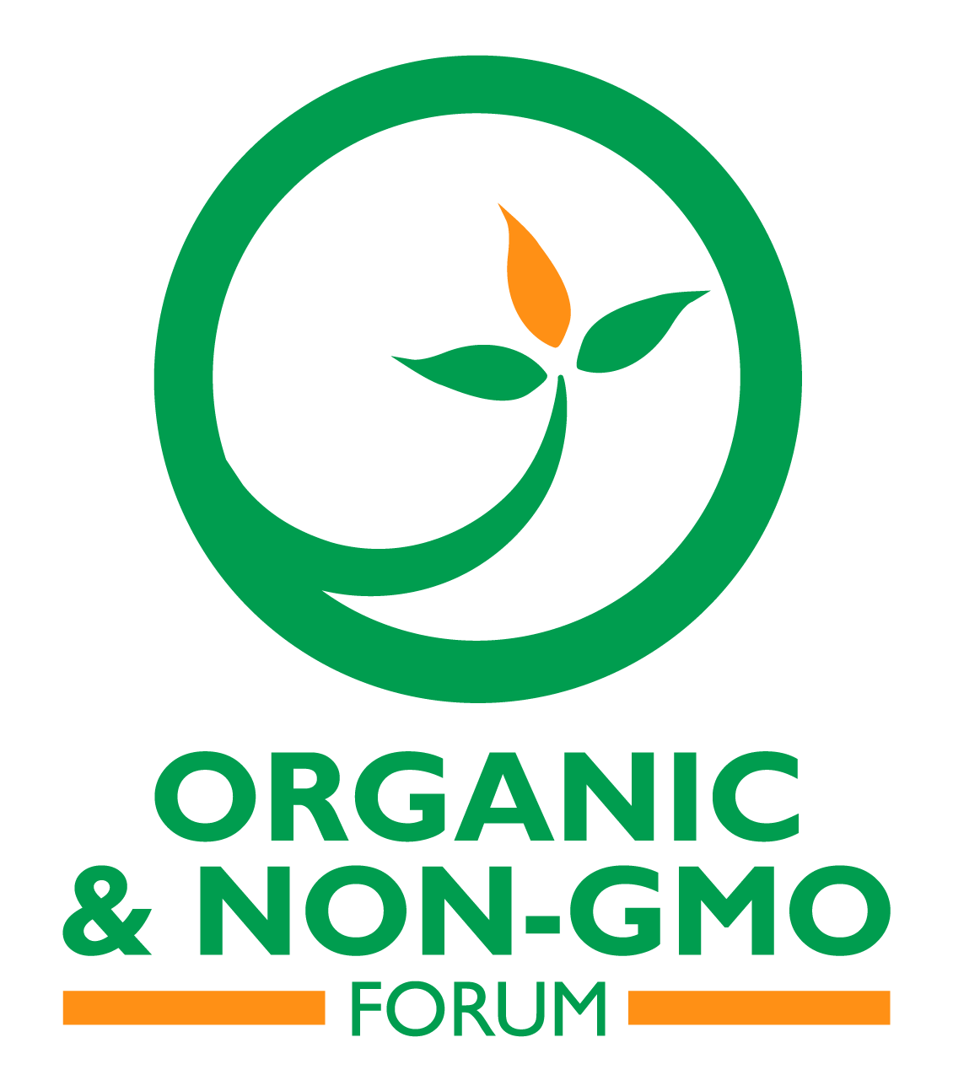
Emily Whiston of EnviroLogix, a global leader in the development of rapid GMO and mycotoxin detection technology, will speak on the radical transformation that CRISPR and other gene editing tools can have in agriculture, and how the industry is reacting to this. Special attention will be given to which technologies qualify as genetically modifying, and where the industry sits on that fence.
From the Center for Science in the Public Interest, Gregory Jaffee, biotechnology project director, will present “Potential Impacts of the USDA’s National Bioengineered Food Disclosure Standard”. This eagerly-awaited new set of laws are destined to become the benchmark for all things scientifically-created or altered in the food world, helping to define “bioengineering” and the threshold for GMO presence in a food product. Additionally, the standard will establish uniform labeling for disclosing information about bioengineered food and food ingredient content.

Jaffee’s perspective as an international expert on agricultural biotechnology and biosafety will provide a comprehensive view of what’s to come with this new legislation.

Following along creating a seamless and transparent sector for consumers and operators alike, Gwendolyn Wyard, vice president of regulatory and technical affairs for the Organic Trade Association (OTA), will shine a light on the ongoing concerns about food disclosure and fraud in the organic sector.

In “Addressing Vulnerability to Fraud: A GOSCI Task Force Update”, Wyard will highlight the efforts of the Global Organic Supply Chain Integrity (GOSCI), which is a 48-member trade group formed in 2017 by the OTA to develop a fraud prevention program designed specifically for the organic industry. Thus far, the group has created a comprehensive “best practices” guide to facilitate the industry-wide implementation of systems and measures to preserve the integrity of organic, both inside and outside of the U.S., and is presently overseeing a pilot to prevent and detect fraud in the global organic system.

Attendees to the Organic & Non-GMO Forum, hosted by HighQuest Group, will be privy to all the details surrounding these critical topics, and the opportunities and challenges they present across the entire agricultural value chain. Learn more at www.ongforum.com or @ONGforum.
_____________________________________________________________________
HighQuest Group, based in Danvers, Mass., is a strategic advisory, conference and media company serving corporations, financial investors and governments across the global food and agribusiness value chains. www.highquestgroup.com

